**Experiment 1: Create a Static Home Page by using HTML Tags and Forms**

**Aim:** The aim is to create a static home page using HTML

**Tags Used:**

<script>

<form>

<div>

<input> <label>

<h2>

<span>

**Implementation:**

**Output**

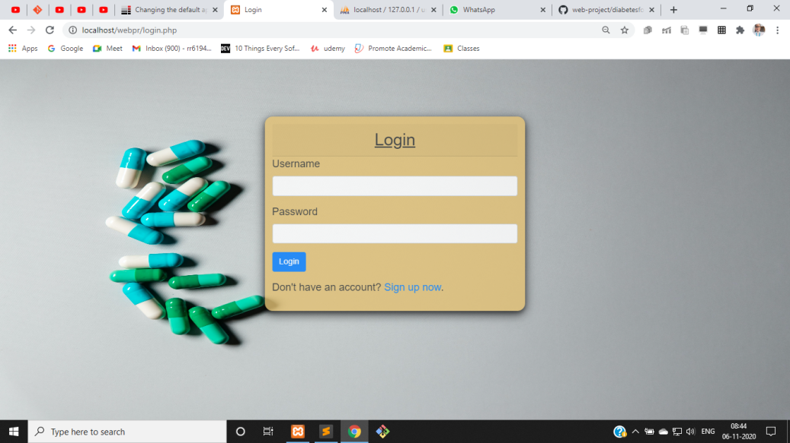

**Code**

Login Page:

<script>

function validateForm() {

var x = document.forms["Login"]["username"].value;

if (x == "") {

alert("Name must be filled out");

return false;

}}

</script>

</head>

<body>

<div class="container">

<h2 class ="text-center card-header"><u>Login</u></h2>

<form action="<?php echo htmlspecialchars($_SERVER["PHP_SELF"]); ?>" onsubmit="return validateForm()" method="post">

<div class="form-group <?php echo (!empty($username_err)) ? 'has-error' : ''; ?>">

<label>Username</label>

<input type="text" name="username" class="form-control" value="<?php echo $username; ?>">

<span class="help-block"><?php echo $username_err; ?></span>

</div>

<div class="form-group <?php echo (!empty($password_err)) ? 'has-error' : ''; ?>">

<label>Password</label>

<input type="password" name="password" class="form-control">

<span class="help-block"><?php echo $password_err; ?></span>

</div>

<div class="form-group">

<input type="submit" class="btn btn-primary" value="Login">

</div>

<p>Don't have an account? <a href="signup.php">Sign up now</a>.</p>

</form>

</div>

</body>

Signup Page:

<div class="container">

<h2 class ="text-center card-header"><u>Sign Up</u></h2>

<form action="<?php echo htmlspecialchars($_SERVER["PHP_SELF"]); ?>" method="post">

<div class="form-group <?php echo (!empty($username_err)) ? 'has-error' : ''; ?>">

<label>Username</label>

<input type="text" name="username" class="form-control" value="<?php echo $username; ?>">

<span class="help-block"><?php echo $username_err; ?></span>

</div>

<div class="form-group <?php echo (!empty($password_err)) ? 'has-error' : ''; ?>">

<label>Password</label>

<input type="password" name="password" class="form-control" value="<?php echo $password; ?>">

<span class="help-block"><?php echo $password_err; ?></span>

</div>

<div class="form-group <?php echo (!empty($confirm_password_err)) ? 'has-error' : ''; ?>">

<label>Confirm Password</label>

<input type="password" name="confirm_password" class="form-control" value="<?php echo $confirm_password; ?>">

<span class="help-block"><?php echo $confirm_password_err; ?></span>

</div>

<div class="form-group">

<input type="submit" class="btn btn-primary" value="Sign Up">

</div>

<p>Already have an account? <a href="login.php">Login here</a>.</p>

</form>

</div>

**Result:**The experiment was successfully completed.